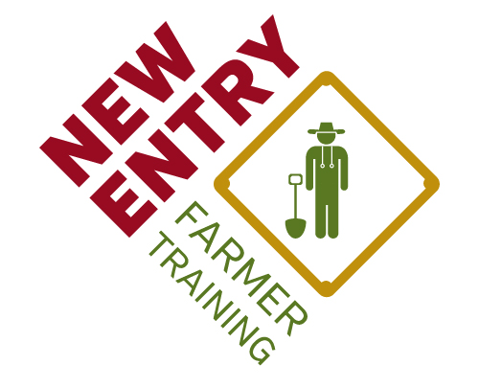
Farm Business Planning Course
Distance Learning Syllabus
Fall 2014

Instructor Information
TBD, Teaching Assistant
- Email:
- Skype:
- Google+:
- Phone:
- Online office hours:

Wendy Mainardi, Farm Business Educator
and Distance Learning Coordinator
- Email: wendy.mainardi@gmail.com
- Skype: WendyMainardi
- Google+: wendy.mainardi@gmail.com
- Phone: (973) 224-4321
- Online office hours: Mondays, 6:00-8:00pm

Course Objectives

- To identify goals and timelines for your farm enterprise
- To identify the resources available to you to start a successful business
- To identify the crops/livestock/value-added products you want to market
- To develop the individual elements necessary for an effective farm business plan
- To weave those elements together into a cohesive business plan

Course Modules

- Week #1: Introduction to Distance Learning & Course Expectations*
- Week #2: Introduction to Farm Business Planning
- Week #3: Enterprise Selection
- Week #4: Marketing and Sales; Live Webinar/Student Sharing Session
- Week #5: Crop Planning and Production Optional: Livestock Production
- Week #6: Equipment and Supplies Sourcing
- Week #7: Writing Business Plans I: Startup Budgets & Farm Financials
- Week #8: Writing Business Plans II: Building the Business Plan

Office Hours

Virtual office hours will be held each Monday evening from 7:00pm to 9:00pm. The instructor and the TA will be available by gchat, phone, email, google+ video chat, and Skype during these times to provide technical assistance. Limited other time slots are available by appointment. Students may receive up to one hour of technical assistance each week.

Technology Requirement

A computer with a reliable Internet connection and the software necessary to use the Internet to communicate and access information and resources are fundamental to participating effectively as a distance learner. Basic understandings of email, video chatting, website navigation, and Microsoft Office programs (Word, PowerPoint, Excel) are also important.

Expectations

As a participant in the online course, you are expected to complete each module fully (including all course materials, discussions, assessments, and evaluations) and to submit all homework assignments. We anticipate a minimum time commitment of approximately 5 hours per week in order to complete this coursework.

In addition, at the conclusion of the course you will be required to submit a completed business plan in full to the instructor(s). The finalized business plan will be due on Sunday, December 21st. Provided that your final business plan is completed on time, you will receive a full review of your plan by the instructors according to the Business Plan Evaluation Rubric. This tool will help you to understand the strengths and weaknesses of your plan and how it might be improved in the future.

Fall 2014 Distance Learning Course Schedule

Mandatory Course Introduction Meeting
Sackler Building, 145 Harrison Avenue, Boston, MA 02111
Saturday, October 18
10:00 AM – 1:00 PM
Due Date | Module | Assignments to be Completed
Wednesday, October 22 | Week #1: Intro to Distance Learning and Course Expectations | 1. Discussion Forum Post: Why have you joined the course?  2. Farm Business Planning Course Pre-Assessment  3. Module #1 Evaluation
Wednesday, October 29 | Week #2: Intro to Business Planning | 1. Discussion Forum Post: Response to case study  2. Discussion Forum Post: What business plan template fits your needs?  3. Week 2 Learning Objectives Assessment  4. Module #2 Evaluation
Wednesday, November 5 | Week #3: Enterprise Selection | 1. File Submission: Initial enterprise "wish list", and sample budgets for each crop  2. Week 3 Learning Objectives Assessment  3. Module #3 Evaluation
Wednesday, November 12 | Week #4: Marketing and Sales | 1. File Submission: Marketing plan, competitive analysis worksheet, revised enterprise wish list based upon market research  2. Week 4 Learning Objectives Assessment  3. Module #4 Evaluation
Optional Field Trip: Marketing Opportunities
Union Square Farmers Market, Somerville
Saturday, November 15
10:00 AM – 1:00 PM
Wednesday, November 19 | Week #5: Crop Planning and Production | 1. File submission: Submit completed cropping and successions timeline as well as seed calculation worksheet.  2. Week 5 Learning Objectives Assessment  3. Module #5 Evaluation  ADDITIONAL: Submit 2-5 PowerPoint slides for live webinar
Mandatory Live Webinar – Student Sharing Session
Wednesday, November 19
7:00 – 8:30 PM
Wednesday, November 26 | Week #6: Equipment and Supply Sourcing | 1. File submission: Submit completed Improved Crop Planning Sheet, Field Schedules, and Materials Worksheet  2. Week 6 Learning Objectives Assessment  3. Module #6 Evaluation
 | Optional: Livestock Production  *Complete assignments to receive an additional hour of technical assistance | 1. File submission: One-page initial livestock operations plan  2. Livestock Production Learning Objectives Assessment  3. Livestock Production Module Evaluation
Wednesday, December 3 | Week #7: Writing Business Plans I: Farm Financials | 1. File submission: Submit your completed financial documents as well as the month that you anticipate breaking even  2. Week 7 Learning Objectives Assessment  3. Module #7 Evaluation  ADDITIONAL: please review the narrative sections of the SCORE business plan in preparation for next week's session
Wednesday, December 10 | Week #8: Writing Business Plans II: Narrating the Business Plan | 1. Begin compiling previous assignments for final business plan  2. Week 8 Learning Objectives Assessment  3. Module #8 Evaluation
Optional Course Conclusion Meeting
TBD
Sunday, December 21 | End of Online Course | 1. Final Business Plans and accompanying materials submitted  2. Complete Online Course Exit Interview
NESFP Spring Launch & Business Planning Graduation
New Entry Office in Lowell, Massachusetts
Mid-March, exact date and time TBA

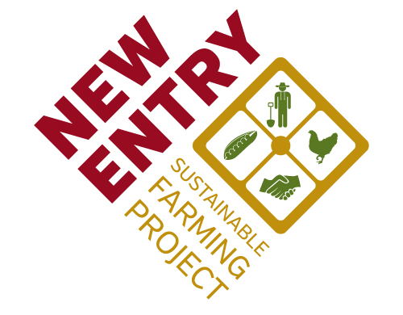

Boston Office:
Lowell Office:
155 Merrimack Street, 3rd Floor
Lowell, MA 01852
(978) 654-6745
75 Kneeland Street
Boston, MA 02111
(617) 636-3793

