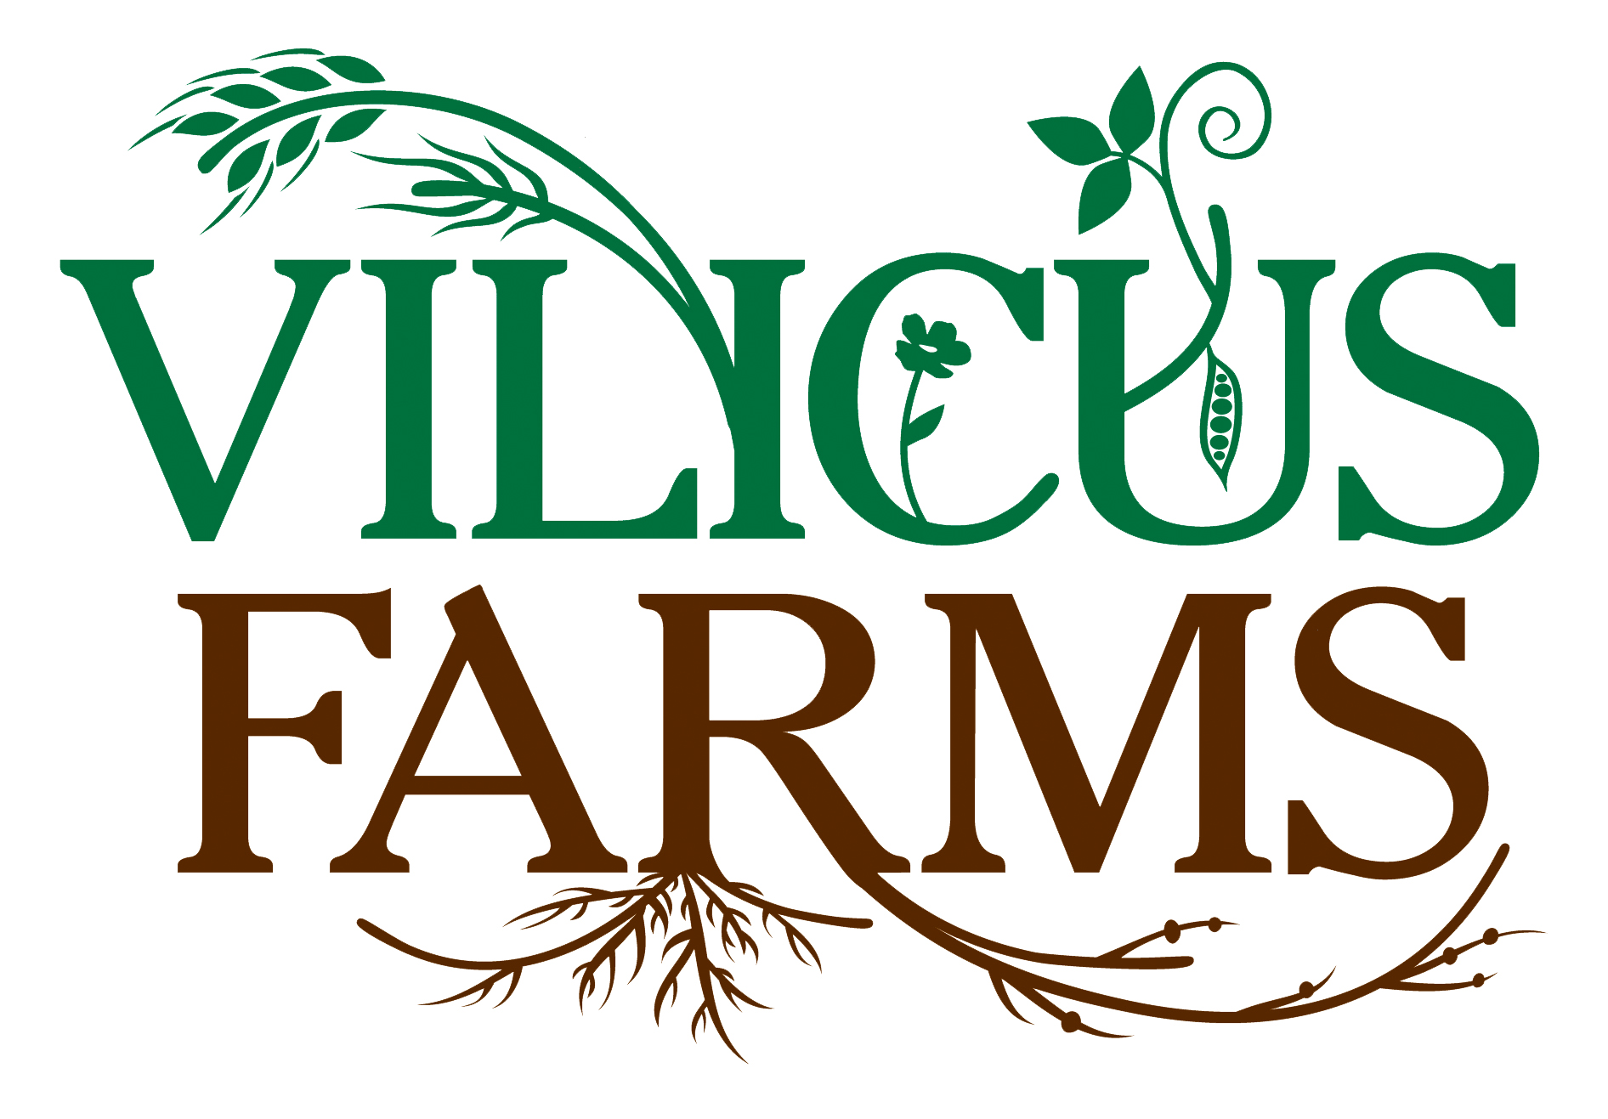

Apprentice Skills Assessment – Immersion Year

Apprentice ______________________________ Date__________________ Reviewed By_____________________________

Skill Area | Skill Elements | Unfamiliar | Observed | Practiced | Independent
Field Operations | GPS
 | Reading Field Maps
Record Keeping in a
Field Operations Log

 | Assessing Soil Conditions
 | Tillage
 | Seeding/Planting
 | Seed Handling
 | Swathing
 | Mowing
 | Cultivating
 | Combining
 | Trucking
 | Manure Spreading
 | Post-Harvest Crop Handling & Storage
Agronomy | Organic Crop Production
 | Conventional Crop Production
 | Local Crop Production MT, Methods/Market
 | Tillage Practices
 | Crop Specific Requirements
 | Crop Rotations
 | Inter-Cropping
 | Weed Management
 | Pest Management
 | Disease Management
 | Crop Scouting
 | Soil Sampling
 | Soil Types/Structure
 | Soil Chemistry
 | Soil Biology
 | Seed Preparation for Crop Production
Equipment | Operation of Clutch & Controls
 | Operation of Hydraulics
 | Operating Front Loader
 | 3-Point & Articulated
 | Hook-Up
 | Maneuvering Semi’s & Articulated Equipment
 | Safety
Service/  Maintenance | Wrenches/Sockets  & Extension Bars
 | Air Tools
 | Heating & Cutting
 | Welding
 | Lubricants
 | Greasing
 | Servicing Oil & Filters
 | Servicing Tires
 | Diagnosing Mechanical Problems
Adjustment of Field
Equipment

Native Environments | Native & Introduced Plant Species
 | Invasive Plant Species
 | Wildlife Habitats
 | Climate Impact
 | Native Pollinator Species
 | Beneficial Species
 | Planting/Maintaining Wind Breaks
 | Managing Soil Erosion
 | Water Conservation
 | Saline Restoration
Business Management | Accounting
 | Crop Records
 | Organic Certification
 | Sourcing/Obtaining Materials
 | Business Plan Development
 | Energy Consumption Analysis
 | Working With Professional Advisors
 | USDA Farm Agencies
Professional Development | Project Management
 | Time Management
 | Public/Professional Speaking
 | Professional Writing
 | Engagement With Farm Organizations
 | Independent Problem Solving
 | Visioning
 | Professional Networking
 | Sponsor/Donor Relations
Political Advocacy/
Lobbying

