Pesticide
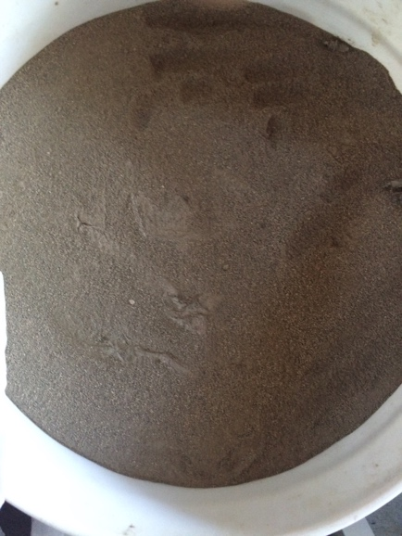
Diatomaceous Earth

How much?

Sprinkle as needed

Sprinkle top and bottoms of leaves or near bottom of plant
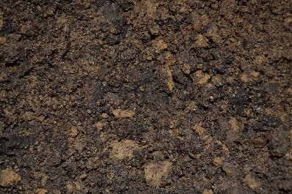
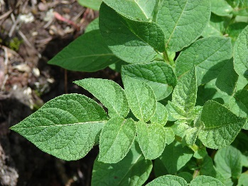

Do NOT use right before rain. After rain re-apply

Use at Dawn or Dusk!!

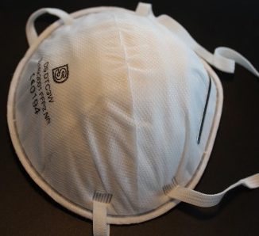
Wear mask

Diatomaceous Earth

Directions

Dry Method
1.) Fill a shaker container with diatomaceous earth. Avoid creating dust by using a spoon to transfer the powder to the container. Although diatomaceous earth is non-toxic, you should not breathe the fine dust. Consider wearing a disposable face mask if you will be working with large quantities of the powder or if you have respiratory issues.
2.)Shake or sprinkle the powder onto the vegetable plants. The best time to do this is in early morning or late evening, when the plants are wet with dew. The moisture helps the dust to adhere to the plant. Diatomaceous earth won’t harm insects when it is wet, but it will be effective once it dries. Shake the powder on the vegetables as well as the leaves; the powder can be easily washed off the vegetables prior to consumption.
3.)Apply the powder to the garden bed and to the area surrounding the garden. This will keep many crawling insects from even reaching the vegetable plants.
4.)Pour a thick ring of diatomaceous earth around the base of plants to deter snails, slugs and squash bugs.
5.)Spray the vegetable plants with a garden hose if it is not the time of year for morning or evening dew. Wait until the excess water drips from the plants, and then shake the powder on the damp plants.

Wet Method
1.)Pour 4 tablespoons of diatomaceous earth into a 1-gallon jug of water. Seal the jug and shake to dissolve the powder.
2.) Fill a spray bottle with the mixture.
3.)Spray the plants until they are wet but NOT dripping. Spray the undersides of leaves, as well. This method works well for treating all parts of the plants with diatomaceous earth.
4.)Allow the plants to dry. The water “glues” the powder to the plants. Once the plants dry, they will have a thin, even coating of powder. This spray method also works well in windy conditions, when it would be difficult to use the shaker to dust the plants.

Storage

Store in a dry place

Where to Buy

Country Farm and Home
101 S Small Street, Pittsboro, NC 27312

Fifth Season
106 S Greensboro St Ste D, Carrboro, NC 27510

Southern States
300 N. Greensboro St., Carrboro, NC 27510

Internet (shipping will be expensive $$$)

Cost
10 lb: $20.00
50 lb: $60.00

