 | FARMERS MARKET | CSA | WHOLESALE | RESTAURANT
 | 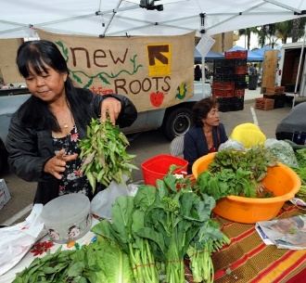 | 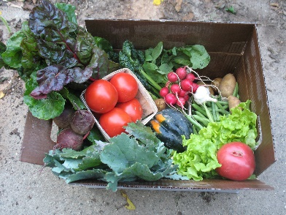 | 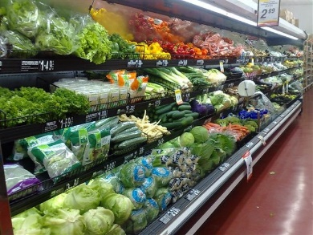 | 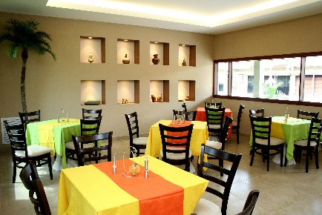
DO YOU NEED A LOT OF TIME?

IS THE MONEY GOOD?

DO YOU NEED MANY DIFFERENT VEGETABLES?

DO YOU NEED TO SPEAK A LOT OF ENGLISH?

DO YOU NEED TO WRITE A LOT OF ENLISH?

DO YOU NEED TO HAVE YOUR OWN CAR?

