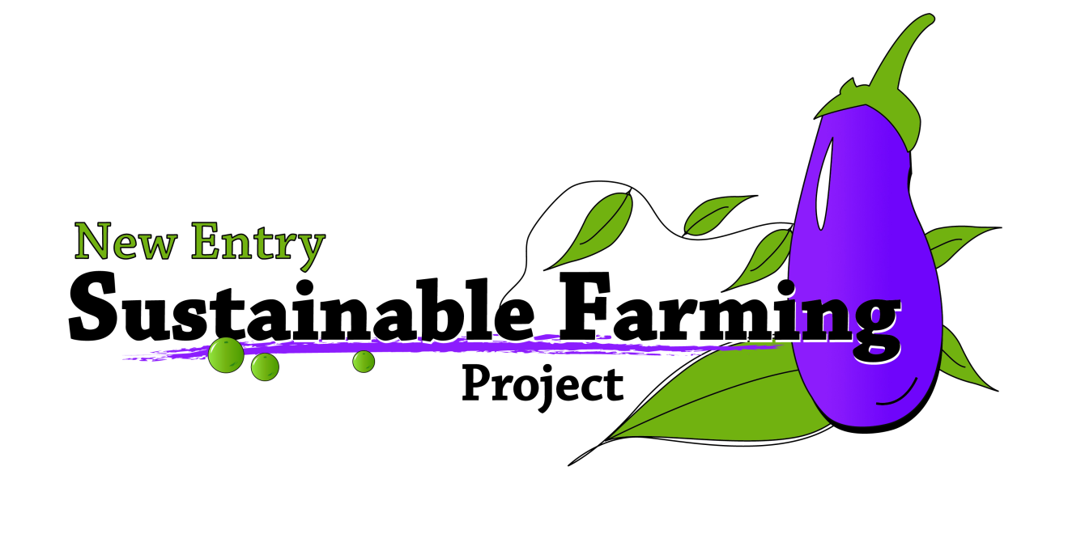

Class # 1: FBC Introduction, Marketing and Sales

Learning Objectives:

- Introductions, orientation to facility headshots and filling out forms
- Learn your marketing options
- Learn how to do basic market research
- Learn how to apply your market research to your farm business plan (marketing plan, financial documents, supporting documents)

Materials:

- Laptop and PPT presentation
- PPT projector
- Calculators
- Calendars
- Marketing materials
- Create a pricing worksheet so that participants will know how much to sell their stuff for when they’re making their cash flow, income projections
- Marketing case studies

Worksheets:

- Sales projection templates (just for review, familiarize students with these)
- Cash flow worksheets (“ “)
- Break even analysis worksheets( “ “)
- Competitive analysis spreadsheet, including pricing column
- Marketing plan write up example

Procedure:

I. Introductions and Class Norms 5:30-6:00
1. Sign in sheet
2. Settling folks in, taking their "head shot" photo, getting them
used to the facility.
3. Pass out media release forms and bio sheets- have students complete them
4. Collecting payments
5. Collecting background/bios and media release forms
6. Class norms, rules and expectations
7. Reviewing what we will cover in classes (refer to revised syllabus)
8. Introduction to NESFP: programs and services. Who are we?
9. Begin class with ice breaker:

II. Learn your marketing options 7:00-7:30
- Begin session with the marketing activity:

Activity: Marketing materials

Marketing and promotional materials will be on display before class begins. Students will walk around the room and find one flyer/brochure that they think is effective, and one that is not. Students will discuss with the class their reasons for choosing what they like and dislike. Guidance and facilitative questions will be provided by instructors.

- Begin PowerPoint Presentation

Slide 1:
This is an overview of your marketing options and the basic components and the things you need to consider before, during and after you create your marketing plan. We will go over all of these points in the presentation during the first half of class and will revisit two major points after the break- identifying customers (and therefore products, prices, quantities, etc) and identifying competition. The first half of this class is being used as an introduction to these things and preparing a context for the second, more “working” half of this session.

Slide 2:
Here we will talk about what marketing options you have available to you. The sky is the limit. You might have a few types of markets in mind right now that you’d like to potentially access. Take the time now to write a few of your initial thoughts down- we will revisit them throughout this session and throughout this course.

Slide 3:
What is a direct market, and what benefits are there to marketing your products directly? Direct marketing is when farmers approach potential customers directly with products. The advantage to direct market channels is that they cut out the middle man and keep more of the profit in the producer’s pocket. One of the potential disadvantages of accessing direct market channels is that producers often times have a more limited ability (resources etc) to reach out to potential customers than would a larger (middle man) distributor. What are some examples of direct market channels?

Slide 4:

What is an indirect market, and what benefits are there to marketing your products indirectly? Indirect marketing is when farmers sell their products to a middle man- not the end user. Potential advantages to accessing indirect market channels include not having to afford the marketing expenses that direct market channels demand- also, the producer is not responsible for pricing or presentation of the product at its market end. Product shrinkage at the market in direct channels is the producer’s loss- while shrinkage in an indirect market channel (for example, if not all the broccoli sells once it’s in the supermarket) is the middle man’s loss. The major disadvantage of selling to indirect market channels is price- producers tend to realize a smaller margin of profit when selling to indirect market channels. Can you think of any exceptions to this?

Slide 5:
You have to decide what you want in order to know how you’re going to get it. Set some goals- financial, personal etc and know what works for you in terms of marketing. Perhaps it’s important that you sell all of your products directly to customers- but perhaps you’re the kind of farmer who would rather wholesale your product. The main goals of your marketing plan will be to describe what kind of marking approach you will take in order to make your enterprises viable by talking about who, where, what, how, how much, and when you’re going to sell your goods.

Slide 6:
Is it important to diversify your markets? Absolutely. A diverse marketing strategy, above all else, helps you manage your marketing risks. Markets can be nebulous, dynamic, and uncertain. If you have chosen to diversify your markets, you reduce your chances of overall failure. If you plan only one market, you put 100% of your stake in that market. If that market fails, your entire operation fails. If you decide to spread your risk out over many markets you reduce the risk of losing everything because you have spread your risk over several markets. On market may fail, but it’s not likely that all markets will fail.

Slide 7:
Your plan is your plan. It is in place so that you can meet your unique goals. Your plan is different than your neighbors plan, than your competitors plan and everyone else’s plan for a multitude of reasons: you may have different drivers and goals, you may be trying (and needing) to access different markets, you may be selling different products, and your need to do all of this uniquely is of great importance to the health and viability of your business. Are there any other reasons you can think of why your marketing plan should be unique? Are there any downfalls to a unique marketing plan?

Slide 8:
You must think of promoting your business with everything you do. One of the first things a startup needs to do is get its name out there. You can do this by making flyers and brochures, getting a business card, creating a website, getting your farm business posted at other hosting sites such as localharvest.org, NOFA, MDAR and farmfresh.org. If you plan on selling at market or a CSA location, you should consider signage for your table and/or vehicle. Promotion is everything. Whenever you have interactions with the public or potential customers, make sure they do not leave empty handed. Be sure to part ways after having given them any outreach material you have, a way to learn more about your business and a way to contact you, preferably in the form of a business card. Where do you think you’d be likely to run into potential customers? Where do you think you would post your flyers or brochures?

Slide 9:
From this point on, we will talk about the parts of your plan and how you can collect data (ie. do the research) that will be reflected in your marketing plan. Important parts of the plan that we will talk about now are: economics, product, customers, competition, niche and strategy.

Slide 10:
Market research is an essential component in the success of your plan and your business in general. It is important for you to recognize that the factors that influence markets (economic, political, cultural, legal etc) are dynamic. Since the factors that influence markets are dynamic, it can be said that the market itself, then, is dynamic. As a business owner it is important to keep a pulse on the market and the trends that influence it, so that you can adjust your strategy and be one step ahead of the competition, or changing trend. Here are some “quick and dirty” ways to begin your market research, (partially adapted from SCORE’s, “60-second Guide to Conducting Market Research”): identify information about your potential customers that will help you know what they need, and how you can help fill that need: demographic information, traffic patterns (to know where to set up shop), to produce quality, type and quantity needs. You can capture this information with surveys. Review information available to the public about your industry- US Census, Chamber of Commerce, Cooperative Extensions are just a few places to start your search. You can collect information about the market in your daily life by observing trends around you, prices, products, packaging, layout, at farm stores, farmers markets, grocery stores etc. Carry a pocket-sized notebook with you so you can record your day to day observations. Keep in mind though, that your goals and driving forces may be very different from the other business you’re observing. Very importantly, talk to people. Talk to restaurant owners, to people entering or exiting a grocery store. Talk to your friends, neighbors and potential customers to get a sense of what they really want. Be sure to engage in conversations prepared to leave your contact information and any promotional materials you have. Be professional when interacting with the public and your potential customers.

Slide 11:
Here you need to talk about facts of your market including: total size, what percent share of the market will you have, (this is important only if you think you will be a major factor in the market), current demand in target market. You should also consider trends in target market—growth trends, trends in consumer preferences, and trends in product development, growth potential and opportunity for a business of your size.
What barriers to entry do you face in entering this market with your new company? Some typical barriers are:

- High capital costs
- High land costs
- High production costs
- High marketing costs
- Consumer acceptance and brand recognition
- Training and skills
- Unique technology and patents
- Shipping/transportation costs
And of course, how will you overcome the barriers?
It is also important to consider how the following affect your company?
- Change in technology
- Change in government regulations
- Change in the economy
- Change in your industry

Slide 12:
For your farm business this means listing out your enterprises. Describe in detail what your product will be. How do you go about the task of choosing what your products will be? There are factors that you are inevitably bound by: resource base (land, water, infrastructure and equipment) and bottom line. With all of your products, you must turn a profit, so the other constraint you are bound by is economics and bottom line. Some farmers though, choose to raise certain crops or livestock because it’s a quality of life consideration. One thing is for certain though: if you can’t sell it, don’t grow it. Are there any examples where farmers grow something just because they enjoy growing it, not because it actually turns a profit? How could a choice like this work as a viable business decision? Has anyone heard of loss-leader enterprises? How do these fit into a viable business model?

Slide 13:
Identify your targeted customers, their characteristics, and their geographic locations, otherwise known as their demographics. How can you find this information? What steps will What steps will you take to identify your own customers?

Slide 14:
Agriculture can seem less like a business than many other ventures, but a farm can’t remain a farm unless it is paying for itself and it’s operators. Identifying your competition may not seem like a necessary step for an agricultural business because of many factors, but it is a necessary step in the development and ongoing work of your business. (can you think of any reasons farmers are sometimes reluctant to identify and analyze competition?) Just like any other business, farms are selling a product in a competitive marketplace, and it is important to know what you are up against so that you can fill a need in that marketplace. In order to do that, you need to know what needs are already being met, and think of ways to do it differently or better.

Slide 15:
In this slide you see a template for organizing the information you’ll be finding out on your competitors. We will review this tool so that you can use it as part of your market research this week.

Slide 16:
Describe where, exactly, your business fits into all of this. What is your niche? How will customers differentiate your product from that of your competitors’? What need are you filling in people’s lives with your product?

Slide 16:
Here is where you outline a marketing strategy for your product that is consistent with your niche. Go into detail about the 4 P’s in order to outline and build a solid strategy. Your strategy will be based on the 4 Ps’, otherwise known as your marketing mix- product, price, place and promotion. Where the 4 p’s overlap is where you will find your market niche. Can anyone give me an example of this theory?

III. Learn how to do basic market research: RESEARCH REDUCES RISK!!

Lecture Portion 7:45-8:00

a) Demographics: IDENTIFY CUSTOMERS
  - Definition
  - What purpose does this data serve?
  - Where can the data be accessed?
b) Paring down demographic information
  - What does YOUR customer look like?
  - How many potential customers are there?
  - What purpose does this data serve?
  - Where can the data be accessed?
c) Market analysis
  - Take advantage of what others have learned
  - Where can you access information that others have produced?
    - Other producers who have your product
    - Libraries
    - Reports and journals
    - FSA (provide #)
    - UMass Extension (provide #)
  - Be precise about your questions, the narrower your question, the easier it is to come up with a useful answer.
  - Talk to people
    - Focus groups (maybe later in your production)
    - One-on-one interviews
d) Analyze your competition: IDENTIFY COMPETION
  - Based on location
  - Based on products and services
  - Based on size, capacity and populations served
  - Pricing, packaging: TAKE NOTES and remind students that when pricing your goods, it’s important to be aware of how much those things cost you to produce. You learned this with your enterprise budgets. The more information you have, the better positioned you are to succeed. Just because someone is selling carrots for $1 doesn’t mean you can afford to do that!
    - Create your marketing strategy based on what you have learned from the above information. Present class with a marketing strategy mock-up to use as a guide in creating their own narrative.

ACTIVITY: 8:00-8:20

Do the case studies in small groups and facilitate discussions.

III. Learn how to apply your market research to your farm business plan 8:20-8:35

After going through where to source your markets and how to determine products and prices for your products, you will have real numbers that you can apply to your cropping schedule (WHICH COMES A BIT LATER). You will then be able to:
- Create a sales projection
- Create an expense forecast
- Create a cash flow statement
Go through each of these documents on the overhead with the class and teach participants how plug their information in.

ACTIVITY: 8:35-8:50

Give the class practice sheets for the above mentioned documents and some mock data. Have participants practice working through the documents in class before doing their own for homework.

After the above documents are done, participants will be able to start the marketing plan section of the farm business plan. Remind the class that they will now be able to start working on the last parts of the b-plan literature; the operations plan and executive summary. Next class though, next steps.

Post assessments handed out and completed. 8:50-8:55

At this point, REMINDERS of what participants will have created with market research and how this fits into whole farm business plan: 2 min
a) Initial enterprise list
b) cropping and succession schedule (later class)
c) cropping and succession timeline (later class)
d) startup budget (later class)
e) a sales projection (eventually, after production/timing planning)
f) a cash flow statement (eventually, after production/timing planning)
g) break-even analysis (eventually, after production/timing planning)
h) a competitive analysis
i) one page marketing plan

ALSO: provide participants with resources and videos and ways to learn beyond this class!! Bring in some of the DVD’s and have the SARE articles available and the book listings written on the board!

- Have staff and interns take photos of the class.

Homework
  - Fill in competitive analysis worksheet so that you can work on the other financial data
  - for the farm business plan class.
  - Include in the competitive analysis a “pricing out” list
  - Do your initial market research.
  - Make an initial enterprise list

Announcements
1) Next week’s session: Intro to Business planning.
2) Check in about field trip dates.

Sources and Resources:

- Evans, David. SCORE advisor interview on October 3, 2007. Market Research.

- SARE Bulletin. “Farm-Based Marketing Research.” (need to follow up on this, found it as a copy w/out much more source information)

- SARE Sustainable Agricultural Network. “Reap New Profits: Marketing Strategies for Farmers and Ranchers.” PowerPoint DVD

- SCORE Competitive Analysis Spreadsheet 2007. Available online at: www.score.org.

- UW-Extension. “Resources for Entrepreneurs”. Online Article at: www.uwex.edu/ces/cced/entrepreneurs/ResourcesforEntrepreneurs.cfm

- UW-Extension and USDA Risk Management Agency. “Farmers Market.” DVD made available in the NESFP resource library.
- .

- For farmer continuing education:

- Building a Sustainable Business: A Guide to Developing a Business Plan for Farms and Rural Businesses. Sustainable Ag Network $14. (802) 656-0484.

- Successful Marketing Research: The Complete Guide to Getting and Using Essential Information About your Customers and Competitors. Wiley, John and Sons. $19.95. (800) 225-5945

